python

Name:Sanjivani singh

Roll no:SE56

Q1 Create class Time. Define three instance variable hour, minute and second. Overload ‘+’operator to add two Time objects, overload ‘<’ operator to compare two Time objects, ‘-‘ operator to find difference between two Time objects.

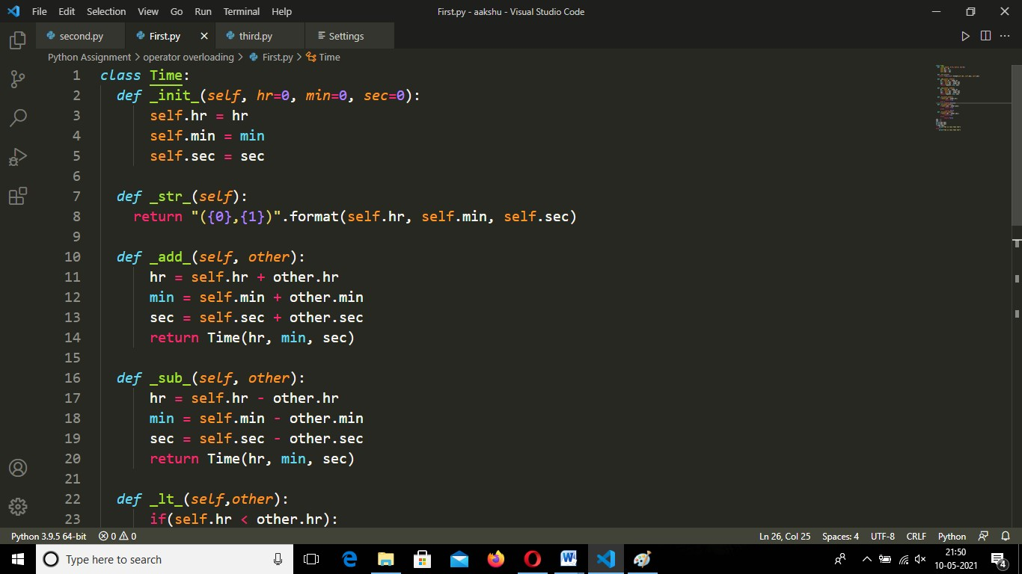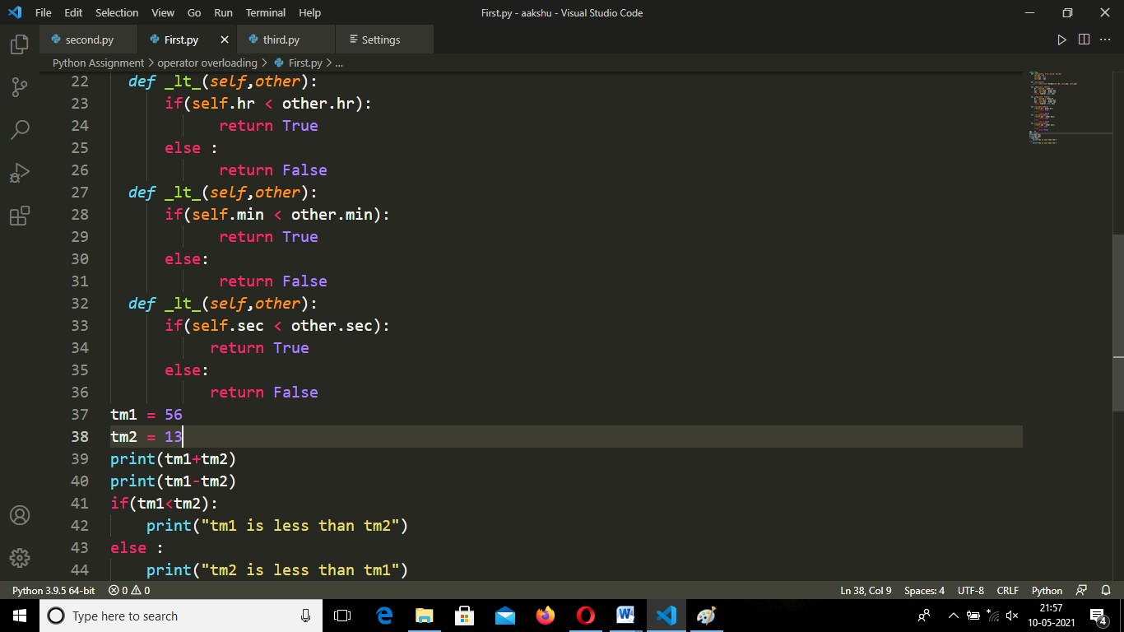

OUTPUT:

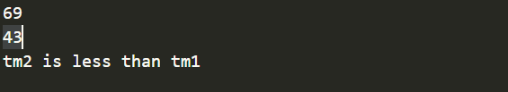

Q2 Create class Distance. Define two instance variable feet and inches. Overload ‘+’ operator to

add two Distance objects, overload ‘<’ operator to compare two Distance objects, overload

‘-‘ operator to find difference between two Distance objects.

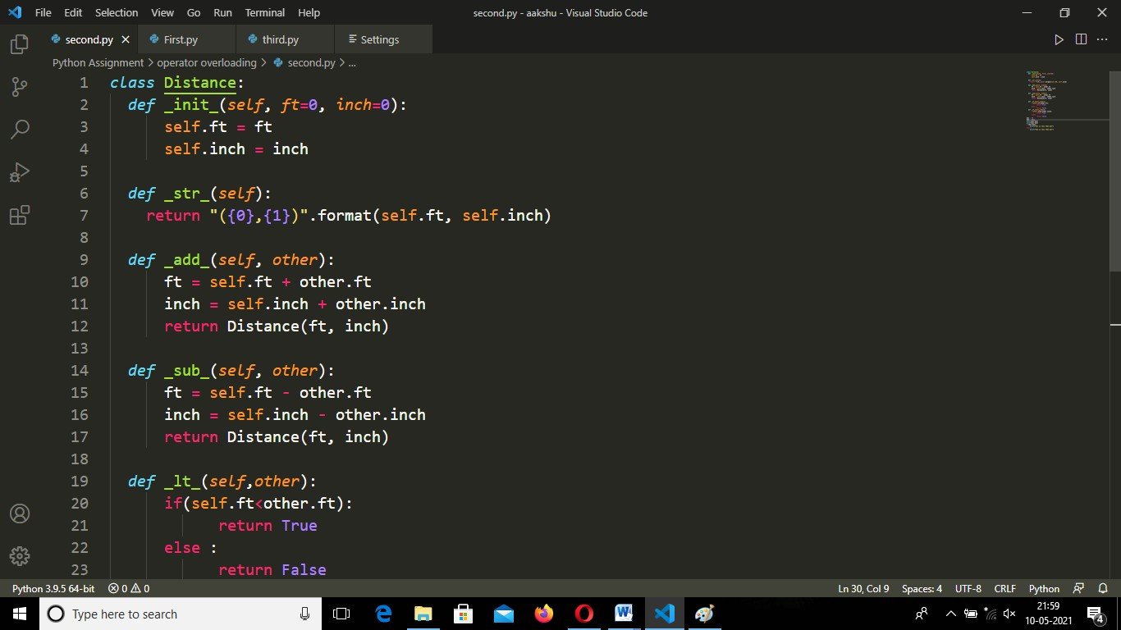

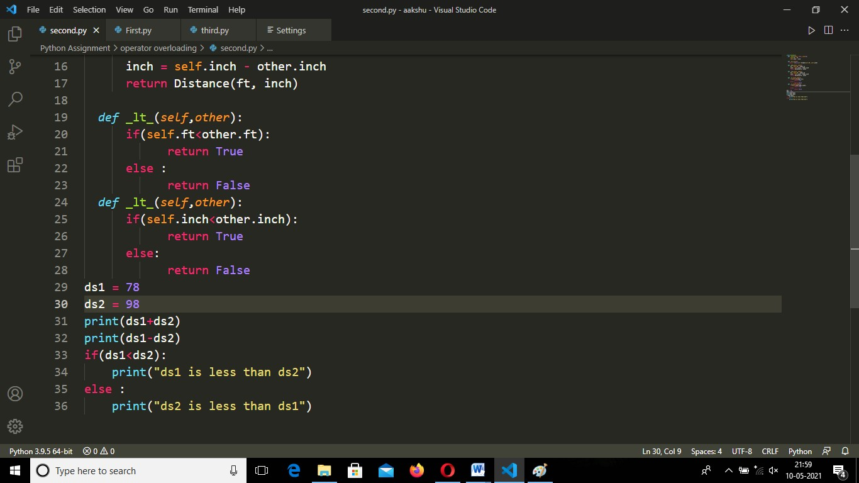

OUTPUT:

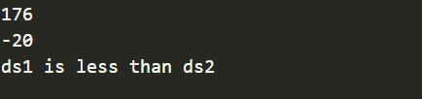

Q3 Create class Vector. Define two instance variable/components of vector x and y. Overload + , - , \* arithmetic operators to add, subtract and multiply two Vector objects. Also overload ‘\*\*’ operator to find mod of a Vector.

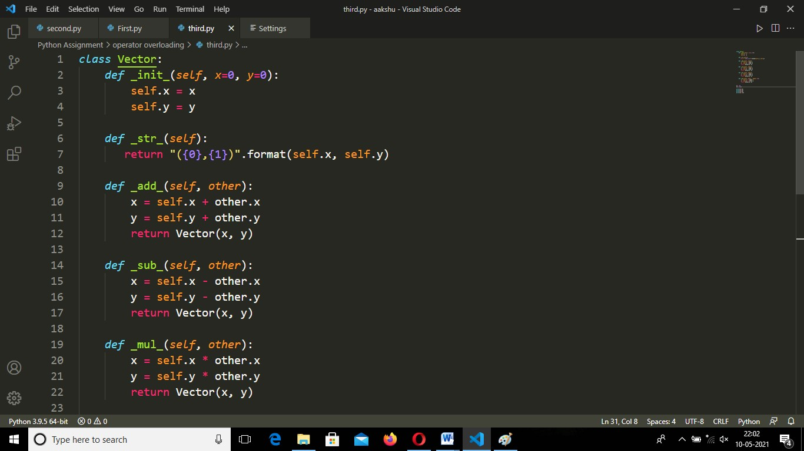

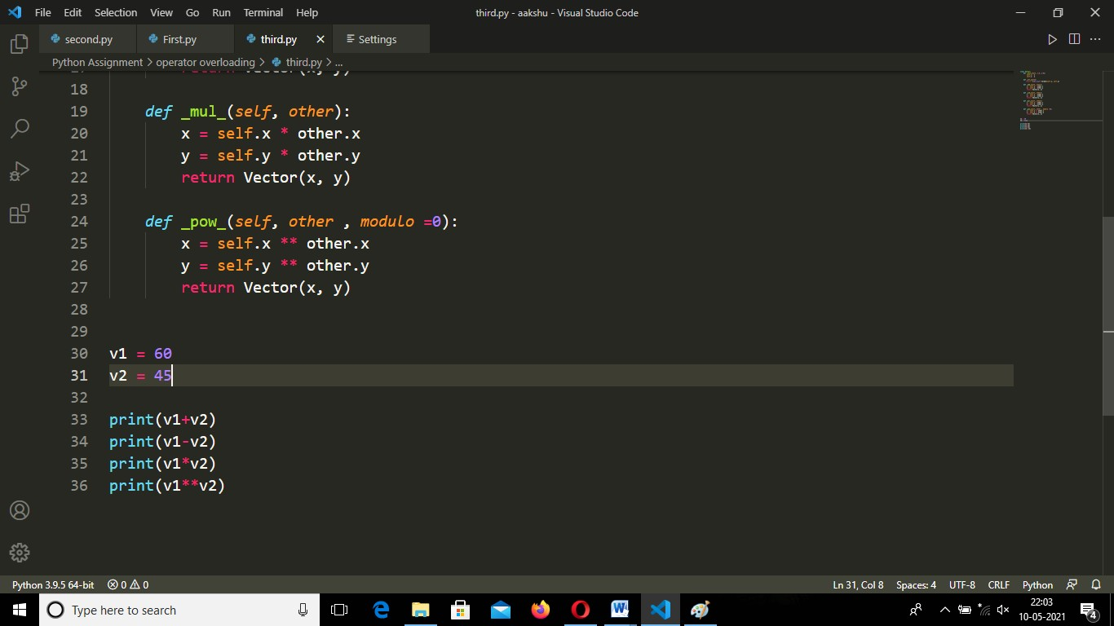

OUTPUT:

